Thomas Hooker

Despite a few internal problems, Massachusetts Bay Colony was thriving by the mid-1630s. It would only be a matter of time before individuals within the colony would consider expansion.
There were obstacles to consider. Establishing a new colony was never easy. Pequot Indian settlements west of the Connecticut River were an important consideration. Nevertheless, the Puritan experiment pushed forward, creating new colonies in the likeness of Massachusetts Bay.
THOMAS HOOKER was a devout Puritan minister. He had no quarrels with the religious teachings of the church. He did, however, object to linking VOTING RIGHTS with church membership, which had been the practice in Massachusetts Bay.
In 1636, his family led a group of followers west and built a town known as HARTFORD. This would become the center of Connecticut colony. In religious practices CONNECTICUT mirrored Massachusetts Bay. Politically, it allowed more access to non-church members.
In 1639, the citizens of Connecticut enacted the first written CONSTITUTION in the western hemisphere. The FUNDAMENTAL ORDERS OF CONNECTICUT called for an elected governor and a two-house legislature. It served as a model for other colonial charters and even future state constitutions after independence was achieved due to the fact that it expanded voting rights for men in the colony.
In 1637, under the leadership of JOHN DAVENPORT, a second colony was formed in the Connecticut River Valley, revolved around the port of NEW HAVEN. Unlike the citizens in Hartford, the citizens were very strict about church membership and the political process. They even abolished juries because there was no mention of them in the Bible. Most citizens accused of a crime simply reported to the judge for their punishment, without even furnishing a defense.
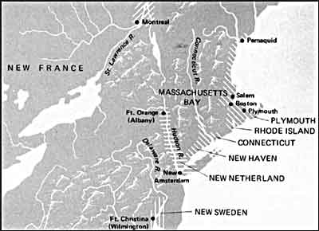
This map shows the area known as the Massachusetts Bay Colony during the 17th century. Settlers soon branched out and settled the areas that would be known as Connecticut and Rhode Island.
New Haven was merged into its more democratic neighbor by King Charles II in 1662.
Connecticut provides a great example of the strictness of colonial society. Laws based on scripture, called BLUE LAWS, were applied to Connecticut residents. Examples include the death penalty for crimes that seem minor by modern standards. Blue laws condemned to death any citizen who was convicted of blaspheming the name of God or cursing their natural father or mother. These laws were in effect at least as late as 1672 in colonial Connecticut.

